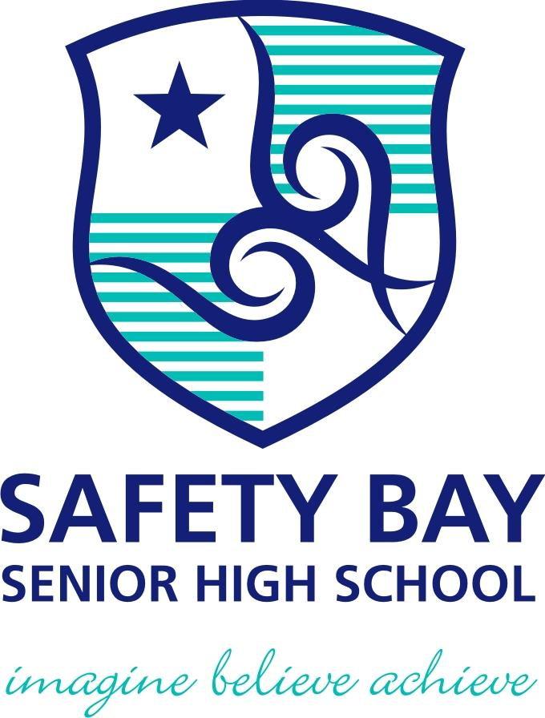

SEMESTER TWO 2017
Waves Test:
ANSWER BOOKLET

NAME: ANSWERS

Multiple Choice Short Answer Total

/15

/15

/30

SECTION ONE: Multiple choice answers
Cross (X) through the correct answer.

1 | a | b | XXXX | d
2 | a | b | c | XXXX
3 | XXXX | b | c | d
4 | XXXX | b | c | d
5 | a | XXXX | c | d
6 | a | XXXX | c | d
7 | a | XXXX | c | d
8 | XXXX | b | c | d
9 | a | XXXX | c | d
10 | a | b | c | XXXX
11 | XXXX | b | c | d
12 | XXXX | b | c | d
13 | a | b | XXXX | d
14 | a | b | c | XXXX
15 | a | XXXX | c | d
SECTION TWO: Short Answer (15 marks)

Answer the questions in the spaces provided.

1. “In Space, no one can hear you scream” is a quote from the movie “Alien”. Explain why this quote is true. (2 marks)
- Sound is a mechanical wave
- Needs a medium to travel
- Space has no medium
(any 2)
2. The audio frequency oscillator was producing the following sound wave on the cathode ray oscilloscope.

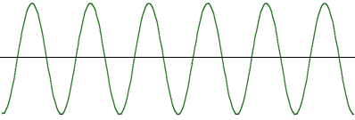
a) Draw below what the wave will look like if the frequency of the sound were to increase (2 marks)
- Same amplitude
- Squishy graph

b) Draw below what the wave will look like if the original sound were louder (2 marks)

- Same graph width
- Taller amplitude

3. Draw a diagram of a light ray hitting a mirror and obeying the Law of Reflection. Be sure to label the normal, the angle of incidence and angle of reflection. (4 marks)

- Normal at 90 to the mirror
- Angle of incidence and angle of reflection is same
- Angle of incidence and angle of reflection labeled correctly
- Arrows drawn on the rays
1 mark each

4. Isaac Newton identified the seven colours of the rainbow.
a) What are they? (3.5 marks)
Red
Orange
Yellow
Green
Blue
Indigo
Violet

(0.5 marks each)

- What are the three primary colours for light? (1.5marks)

- red
- Green
- blue
(0.5 marks each)

